# Introduction

[1-2 para:

Basic demographic data have been recorded for hundreds of years in some European and pan-European nations. The accurate collection of such data has been encouraged in a large number of other nations though the creation of health demographic surveillance systems. These data allow a large number of subtle and complex trends to be identified. The fact that similarly unambiguous data have been recorded in a large number of countries which are more or less close together means that there is opportunity to use these records to make spatial inferences about the changing demographic and health structures of different nations, and factors which may have led to such causes.

The generation and testing of hypotheses can be like a flywheel, with data required both for the confirmatory and disconformatory components of this journey. To aid the generation of hypotheses, effective and appropriate methods of visualisation can be of great benefit in making otherwise hidden patterns much easier to see. As people are prone to type 1 errors, however, the development of formal models which allow the testing of these hypotheses should then follow. The development of such models are important also for allowing the simulation and projection of the trends implied, including appropriately wide bounds of uncertainty.

Within a recent paper, we described two type of enhancements to existing methods for visualising demographic data. These methods were applied to the full range of data from the Human Mortality database, including observations dating back to the late 19th century for almost forty distinct nations. The focus of the previous paper was on introducing these visualisations and how best to read them, the breadth of the data visualised, together with dissimilarities and similarities between visualisations from different countries, indicates that they may be used as a first step for the generation development of formal models which allow incorporate complex area, age, period and cohort trends.

The focus on the present paper is in describing how the visualisations can be used for spatio-temporal hypothesis generation, implying the

This paper represents a call for spatial statisticians to use our visualisations as a starting point for the development of formal spatio-temporal demographic models, which would allow the testing of a range of hypotheses implied by the visualisations, including the spatial influences they imply.

The paper will do the following:

Briefly describe coplots

Describe the idea of the demographic transition and suggest how change-point models might be an appropriate tool with which this development occurred in the nations for which appropriate data are available.

The The rest of this paper is structured as follows. Firstly, the model which a series of enhancements to existing visualisation methods which

Discuss value of visualisation for hypothesis generation

Discuss value of formal modelling for disconfirmation of hypothesis and simulation

Discuss value of spatial modelling for analysis of spatial components of data]

[1 para: summarising structure of paper

* To do last]

## The human mortality database

### 1.1.1 What is the HMD?

[1-2 para

The Human Mortality Database contains demographic data in a standardised format for thirty seven separate nations. It is managed by the Department of Demography at the University of California, Berkley, in collaboration with the Max Planck Institute for Demography Research. For a number of the nations, separate datasets are presented for sub-regions or sub-populations. For example, data for Germany is presented separately for East and West Germany; data for New Zealand is presented separately for Maori and Non-Maori populations; and data for the United Kingdom is presented separately for England & Wales, Scotland and Northern Ireland. Within England & Wales, the data are subdivided into total population and civilian population. Because of this there are a total of 48 datasets from the 37 countries, but not all datasets are mutually exclusive spatially.

The

is a project run by XX of XX and XXX of XX, freely available to researchers, in which the demographic records from a large number of countries have been compiled and presented in identical formats. This allows for the automation of analyses, as syandard formats are used. In the case of our visualisations, this meant that the visualisations were developed for a larger number of nations. For the full dataset.

Th’resolution’ of the images is one year of age by one year of time.

The term ‘lexis surface’ has been used to represent surfaces on which there are three axes, two of which are age and year. Different types of Lexis surface exist,depending on what hte third variable is. (For example, mortality surfaces, morbidity surfaces, etc etc)

What is the HMD?

Compilation of lifetable

Who runs/maintains it?

* Department of Demography, University of California, Berkley
* Data Laboratory, Max Planck Institute for Demography Research (MPIDR)
* Director: John Wilmoth (UCB)
* Co-director: Vladimir Sckolnikov (MPIDR)

Resolution of data – 1 year by one year

### 1.1.2 Spatial Aspects of the data

As fig X indicates, the data available include most European nations over a long period of time. Outside of Europe, data are available for Australia, New Zealand, Taiwan, Israel, Chile and Japan, the United States, Canada

WorldHMD.TIFF

Figure World Map showing countries for which Human Mortality Database (HMD) data are available, coded by duration of data (Year first reported)

a large number of nations. Coverage is greatest in Europe, and so assessment of spatial dependence may be easiest to determine within than beyond Europe. Because of the Which countries

[Map showing where data are available. White maps regions indicate missing data. The darker the shape, the longer back the data go: quintiles?

Approximately:

< 20 years

20 to 50 years

50 to <100 years

100 to <150 years

150 to <200 years

>= 200 years

Australia

|  |  |  |
| --- | --- | --- |
| Country | First Year | Last Year |
| Australia  Austria | 1921  1871 | 2009  2010 |

Which years for each country

Spatial representation of data]

## 1.2 Coplots and contourplots

[1 para: Introduce IJE paper](Minton et al. 2013)

### 1.2.1 Mean-variance Coplots

The previous paper describes coplots

[1 para: brief description of coplot and what they may show]

### 1.2.2 Lexis surfaces and contour plots

[1 para: concept of a mortality surface]

The term Lexis surface was coined by Vaupel and colleagues to describe values varying by age on one axis and year (or year of birth) on the other axis. (Vaupel et al. 1987) Where these values are of mortality rates, then these Lexis surfaces can be called mortality surfaces. Two variations were produced. In the standard variation, one of the axes is year and the other is year. In the alternative variation, year of birth rather than year is plotted. Within the birth year-age mortality surface, cohort effects are apparent as vertical disruptions, and period effects as disruptions running at a north westerly diagonal. By contrast , in the standard year-age mortality surface, cohort effects are vertical disruptions and cohort effects run at a north easterly diagonal. Within this paper, only the standard plots will be presented.

[1 para mentioning that contour plots are a rediscovery, publication by Vaupel et al; precedent in Kermack]

(Vaupel et al. 1987, 1997)

(Kermack 2001)

[1 para – logged and unlogged values, ref to EP A](Minton)

## Key concepts

### Epidemiological Transitions

Ref to: (Wilkinson 1994)(Omran 2005)

### Age, period, cohort Effects

A shopping list for what an appropriate spatial model of the lexis surface should incorporate

## Modelling of key concepts

### Epidemiological transitions

#### Change point models

(Erdman and Emerson 2007; Killick and Eckley 2013)

### APC

#### Age-period cohort (APC) models

#### Spatial extension: Area Age Period Cohort

Ref: (Lagazio et al. 2003)

### Other approaches

#### Spatial models with Clustering and missing data

B Y M?(Besag et al. 1991)

# Epidemiological Transitions

Regardless of whether child mortality has been included or not, there is typically a very strong negative correlation between the mean age of death and the variance around that figure.

Illustrative correlations by country (giving earliest observation)

Factor (A, -B) where A is E(X) and B is var(E(X))

## Description of The Hinge

For many countries where the data stretch back long enough, there is some indication of a characteristic ‘hinge’ shape to the concurrent changes in E(X) and var(E(X)), suggesting a ‘before’ phase, a ‘during’ phase, and an ‘after’ phase to these patterns. The evidence of a

Start point, mid point, end point

## Countries for which appropriate data are available

X:\1918 Cohort\1918\main\Data\meanVarPlots\females\inc\F_inc_BEL.tif

X:\1918 Cohort\1918\main\Data\meanVarPlots\females\inc\F_inc_ISL.tif

X:\1918 Cohort\1918\main\Data\meanVarPlots\females\inc\F_inc_ITA.tifX:\1918 Cohort\1918\main\Data\meanVarPlots\females\inc\F_inc_NLD.tif

## Example of nations with different rates of transition

## Possible model: changepoint models

Changepoint models could be used to identify whether the data are consistent with abrupt changes over time, and the number of these changes. It could be, for example, that some form of logistic regression parameter may be sufficient for modelling such trends, and that models which do not use changepoints have better AIC/DIC.

# Age Effects

## Bathtubs

Ref Gompertz (Gompertz 1825)

## Infant Mortality

Figure: Reduction in Child mortality

The infant and child size of the bathtub has reduced substantially in almost all of the nations for which the records reach back sufficiently far.

For countries for which the records do not stretch back far enough, the spatial proximity of nations means that some degree of additional information could be called on to allow inference and imputation of what hte trends would likely have been.

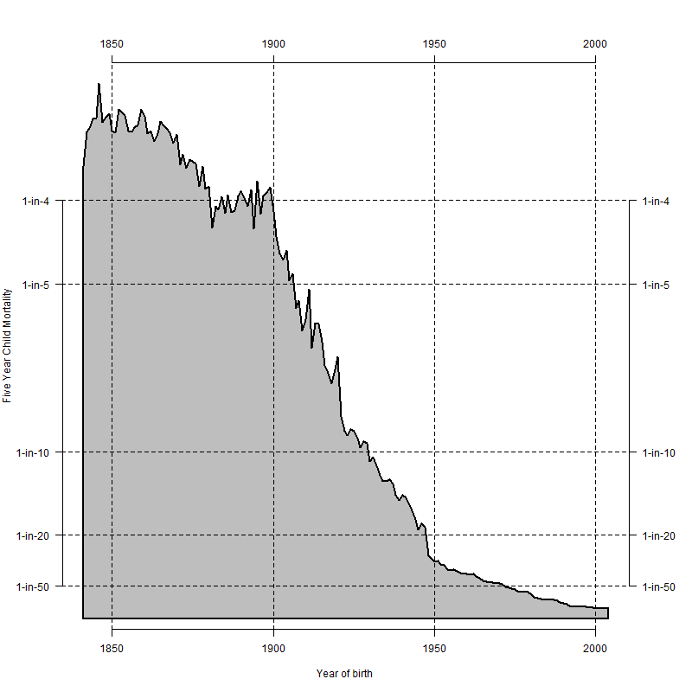

Figure Change in Five Year Child Mortality, Males, England & Wales, 1847 to 2010

## Coming of age effects

Although more subtle than the age effects in infancy and in older ages, many of the visualisations exhibit coming-of-age effects: i.e. once someone reaches young adulthood, then mortality rates rise.

There appears to be a different in the presence/degree of the coming of age effect between genders.

## Coming of ageing effects

Dorling suggests that, once people in England reach the age of 35, something happens to their mortality risk. This was based on data from X. It may be possible to see 1) whether this change point is still observed; 2) whether it has changed over time; 3) whether it has changed between nations.

### Norway

Data for Norway go back a long time. Norway has a relatively hazardous natural environment. The coming of age effect for Norway is particularly pronounced in older years, but (on the unlogged scale) is much harder to detect in more recent years.

### Other maps – logged scale

Using maps of log-mortality rather than mortality make the coming of age effect clearer. Between about the ages of three and sixteen, people have very low mortality rates.

## Mortality in older age

# Period Effects

## Historical Examples – Before the wars

### WW1

### WW2

#### Italy

#### Finland Example compared with Norway

## Russia Example

## Spatial components

### In some nations, civilian populations were more exposed to the effect cf military populations than in others

### Allied Effects & Axis Effects

### Gender effects

### Civilian vs military

For some nations, the data are presented separately for the total population compared with the civilian population. This allows some insight into how much military service was a factor in

### Centrality & Periphery

# Cohort Effects

## 1918 Effect

### Thrifty Metabolism

## (Painter et al.; Roseboom 2000; Roseboom et al. 2001; Elias et al. 2004)

## Later effects

### WW2 effect

[Illustrate with log plots]

## Positive effects

“The “cohort effect” in this context is the observed phenomenon that people born in the U.K. between 1925 and 1945 (centred on the generation born in 1931) have experienced more rapid improvement in mortality than generations born either side of this period.” (Willets 2003)

### Change in rate of change of contours

# Comparison of maps to control for exposure

All mortality data are presented separately for males and females. Additionally, for a number of nations data are reported separately for civilian population compared with the total population.

## Male maps and female maps

## Civilian maps and total maps

# Counterfactuals

## Size of the 1918 effect depends on estimating the counterfactual : no war, no change in births, no change in mortality rates

## Number died in wars similarly requires estimating counterfactuals

## Must be done formally

# Surface projection

## Interpolation

## Extrapolation

### Contours must not cross

### Forwards

#### How will A-P-C effects vary given spatial proximity of countries

### Backwards

#### When did transition occur?

# Discussion

## Application to other sources of data

Latin American Human Mortality Database (Urdinola and Queiroz 2013)

### Health Demographic Surveillance System

### Intranational e.g. city level

The Canadian Human Mortality Database(Wilmoth et al.)

#### Additional covariates known

### Morbidity

## Co-dependence between parameters?

### Spatial ripples?

# References

Besag J, York J, Mollie A. Bayesian Image Restoration, with two applications in spatial statistics. Annals of the Institute of Statistical Mathematics. 1991;43(1):1–20.

Elias SG, Peeters PHM, Grobbee DE, Noord PAH v. Breast Cancer Risk After Caloric Restriction During the 1944-1945 Dutch Famine. JNCI Journal of the National Cancer Institute [Internet]. 2004 Apr 6 [cited 2012 Sep 22];96(7):539–46. Available from: http://jnci.oxfordjournals.org/cgi/doi/10.1093/jnci/djh087

Erdman C, Emerson JW. bcp: An R Package for Performing a Bayesian Analysis of Change Point Problems. Journal of Statistical Software [Internet]. 2007;23(3). Available from: http://www.jstatsoft.org/v23/i03/paper

Gompertz B. On the Nature of the Function Expressive of the Law of Human Mortality, and on a New Mode of Determining the Value of Life Contingencies. Philosophical Transactions of the Royal Society of London [Internet]. 1825 Jan 1 [cited 2012 Apr 11];115:513–83. Available from: http://rstl.royalsocietypublishing.org/cgi/doi/10.1098/rstl.1825.0026

Kermack W. Death-rates in Great Britain and Sweden. Some general regularities and their significance. International Journal of Epidemiology [Internet]. 2001 Aug 1 [cited 2012 May 18];30(4):678–83. Available from: http://ije.oxfordjournals.org

Killick R, Eckley IA. changepoint: An R Package for Changepoint Analysis [Internet]. 2013. Available from: http://www.lancs.ac.uk/~killick/Pub/KillickEckley2011.pdf

Lagazio C, Biggeri A, Dreassi E. Age-period-cohort models and disease mapping. Environmetrics [Internet]. 2003 Aug [cited 2013 Sep 30];14(5):475–90. Available from: http://doi.wiley.com/10.1002/env.600

Minton J. Logs, Lifelines and Lie Factors. Environment and Planning A.

Minton J, Vanderbloemen L, Dorling D. Visualizing Europe’s demographic scars with coplots and contour plots. International Journal of Epidemiology [Internet]. 2013;42(4):1164–76. Available from: http://ije.oxfordjournals.org/content/42/4/1164.full

Omran AR. The Epidemiologic Transition: A Theory of the Epidemiology of Population Change. The Milbank Quarterly. 2005;83(4):731–57.

Painter RC, Roseboom TJ, Bleker OP. Prenatal exposure to the Dutch famine and disease in later life: an overview. Reproductive toxicology (Elmsford, NY) [Internet]. [cited 2012 Aug 9];20(3):345–52. Available from: http://www.ncbi.nlm.nih.gov/pubmed/15893910

Popham F, Mitchell R. Leisure time exercise and personal circumstances in the working age population: longitudinal analysis of the British household panel survey. Journal of Epidemiology and Community Health [Internet]. 2006;60(3):270–4. Available from: <Go to ISI>://000235343800017

Roseboom TJ. Coronary heart disease after prenatal exposure to the Dutch famine, 1944-45. Heart [Internet]. 2000 Dec 1 [cited 2012 Sep 22];84(6):595–8. Available from: http://heart.bmj.com/cgi/doi/10.1136/heart.84.6.595

Roseboom TJ, Meulen JHP van der, Osmond C, Barker DJP, Ravelli ACJ, Bleker OP. Adult survival after prenatal exposure to the Dutch famine 1944-45. Paediatric and Perinatal Epidemiology [Internet]. 2001 Jul [cited 2012 Sep 22];15(3):220–5. Available from: http://doi.wiley.com/10.1046/j.1365-3016.2001.00336.x

Urdinola B, Queiroz BL. Latin American Human Mortality Database [Internet]. 2013 [cited 2013 Oct 1]. Available from: http://www.lamortalidad.org/

Vaupel JW, Gambill BA, Yashin AI. Thousands of Data at a Glance: Shaded Contour Maps of Demographic Surfaces [Internet]. Laxenburg, Austria; 1987. Available from: http://user.demogr.mpg.de/jwv/pdf/Vaupel-IIASA-RR-87-016.pdf

Vaupel JW, Wang Z, Andreev K, Yashin AI. Population Data at a Glance: Shaded Contour Maps of Demographic Surfaces over Age and Time [Internet]. University Press of Southern Denmark; 1997. Available from: http://www.abebooks.co.uk/servlet/BookDetailsPL?bi=2944819605

Wilkinson RG. The Epidemiological Transition: From Material Scarcity to Social Disadvantage? Daedalus [Internet]. 1994;123(4):61–77. Available from: http://www.jstor.org/discover/10.2307/20027267?uid=3738032&uid=2129&uid=2134&uid=2&uid=70&uid=4&sid=21100802164711

Willets R. THE COHORT EFFECT : INSIGHTS AND EXPLANATIONS. 2003 p. 1–38.

Wilmoth J, Shkolnivok V, Andreev K. Canadian Human Mortality Database [Internet]. Department of Demography, Université de Montréal (Canada). [cited 2013 Oct 1]. Available from: http://www.bdlc.umontreal.ca/chmd/